**Assignment 4**

**Freestyle/Pipeline/no. of Jobs**

**Stop Tomcat, Clean Tomcat, Deploy Tomcat, Start Tomcat**

**On Slave1 🡪 label ‘s1’**

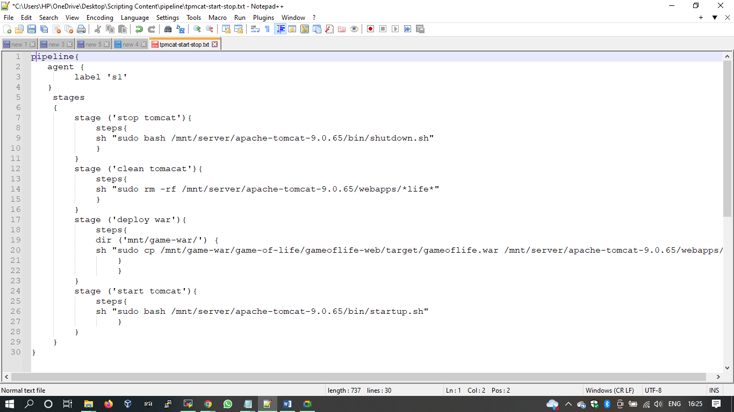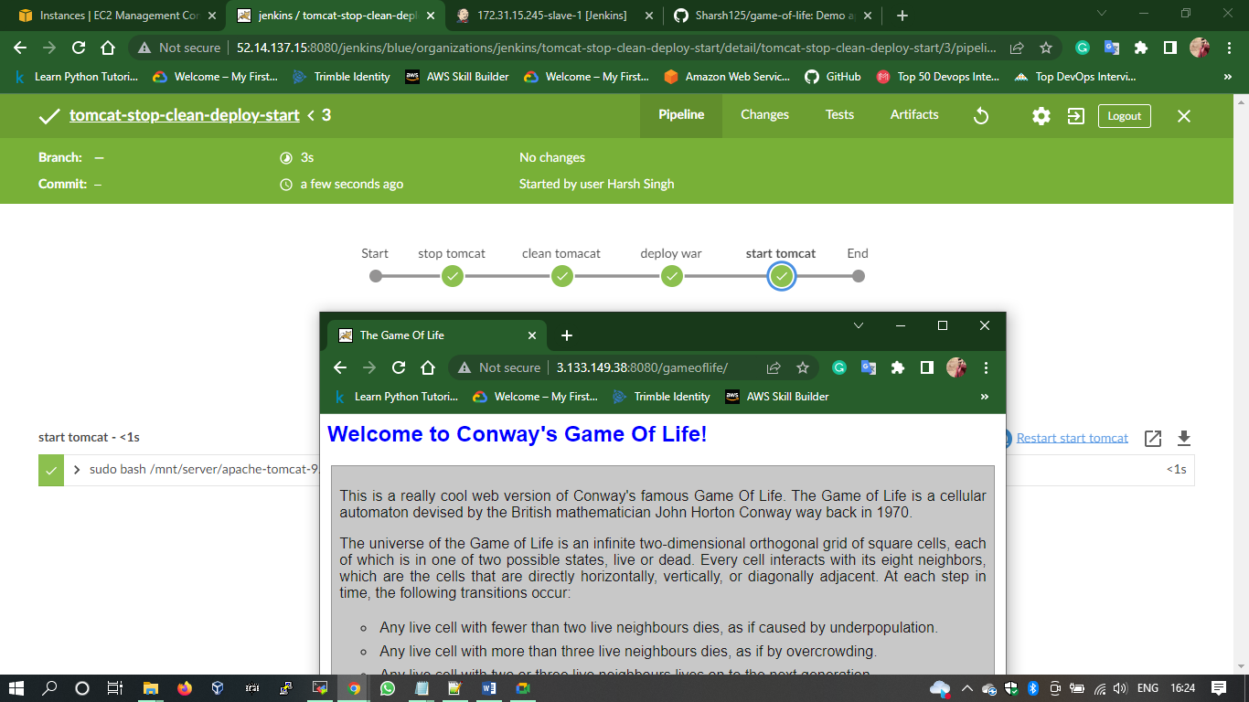

**On Jenkins Master**

